**SCHOOL OF COMPUTER SCIENCE**

**UNIVERSITY OF PETROLEUM AND ENERGY STUDIES**

**DEHRADUN, UTTARAKHAND**



**DATA COMMUNICATION AND NETWORKS LAB**

**LABORATORY FILE**

**(2024-2025)**

**For**

**Vth Semester**

**Submitted To: Submitted By:**

Prof. Abhishek Yadav Mr. Akshat Negi

Assistant Professor S.S. 500106533(SAP ID)

[Vth Semester] R2142220414(Roll No.)

School of Computer Sciences B.Tech. CSF (Batch-1)

**LAB EXPERIMENT – 5**

**Basic Network Commands**

**Set Up the Devices**

1. Drag and drop:
   * **2 PCs** (e.g., PC0 and PC1).
2. **Connect the devices**:
   * Use a automatic cables to connect PC0 and PC1 directly.

**Assign IP Addresses to the PCs**

Manually assign IP addresses to each PC using the **IP Configuration tab**:

**Steps for Each PC:**

1. Click on **PC0**, go to **Desktop > IP Configuration**, and set:
   * **IP Address**: 10.0.0.1
   * **Subnet Mask**: Leave blank for auto configuration to default.
   * **Default Gateway**: Leave blank if no router is used.
2. Click on **PC1**, go to **Desktop > IP Configuration**, and set:
   * **IP Address**: 10.0.0.2
   * **Subnet Mask**: Leave blank for auto configuration to default.
   * **Default Gateway**: Leave blank if no router is used.

**PC Configuration Setup**

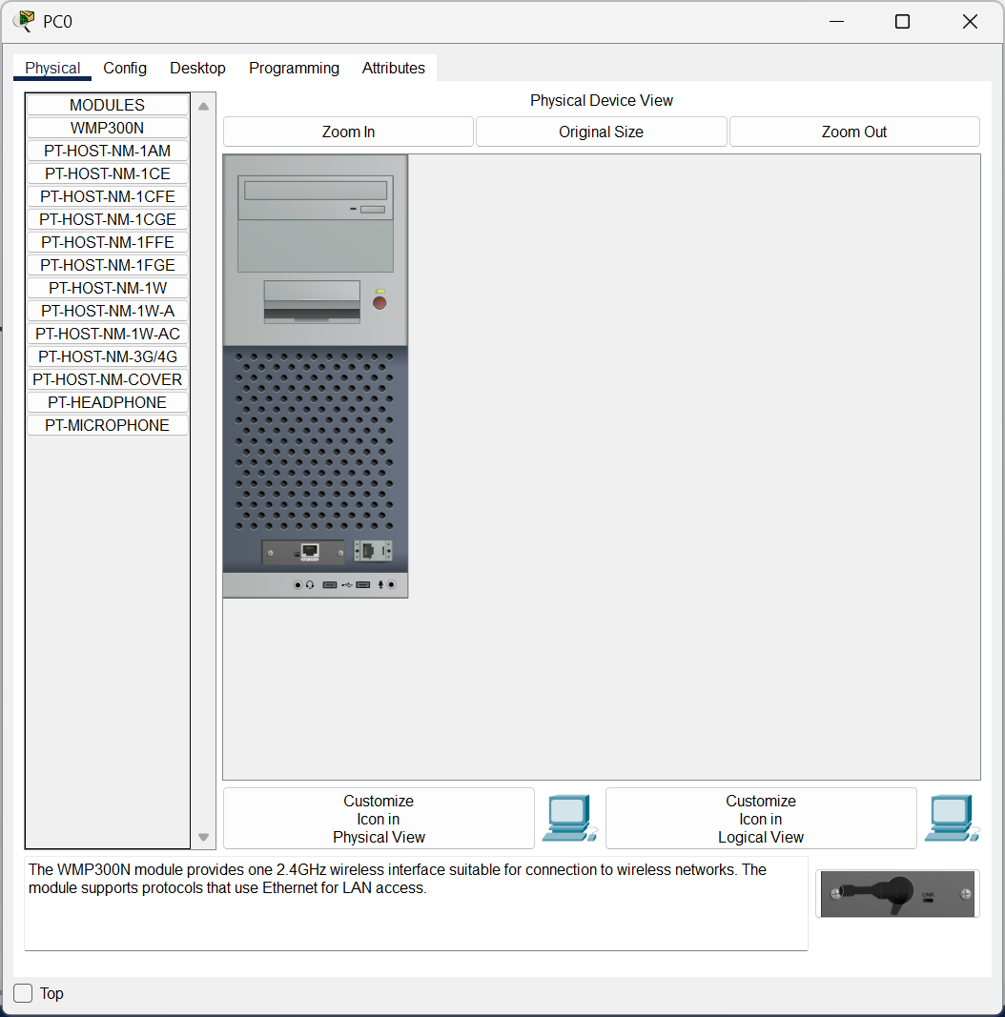

**Open the Command Prompt for IP Configuration Check.**

1. Click on the PC (e.g., **PC0**).
2. Navigate to **Desktop > IP Configuration**.

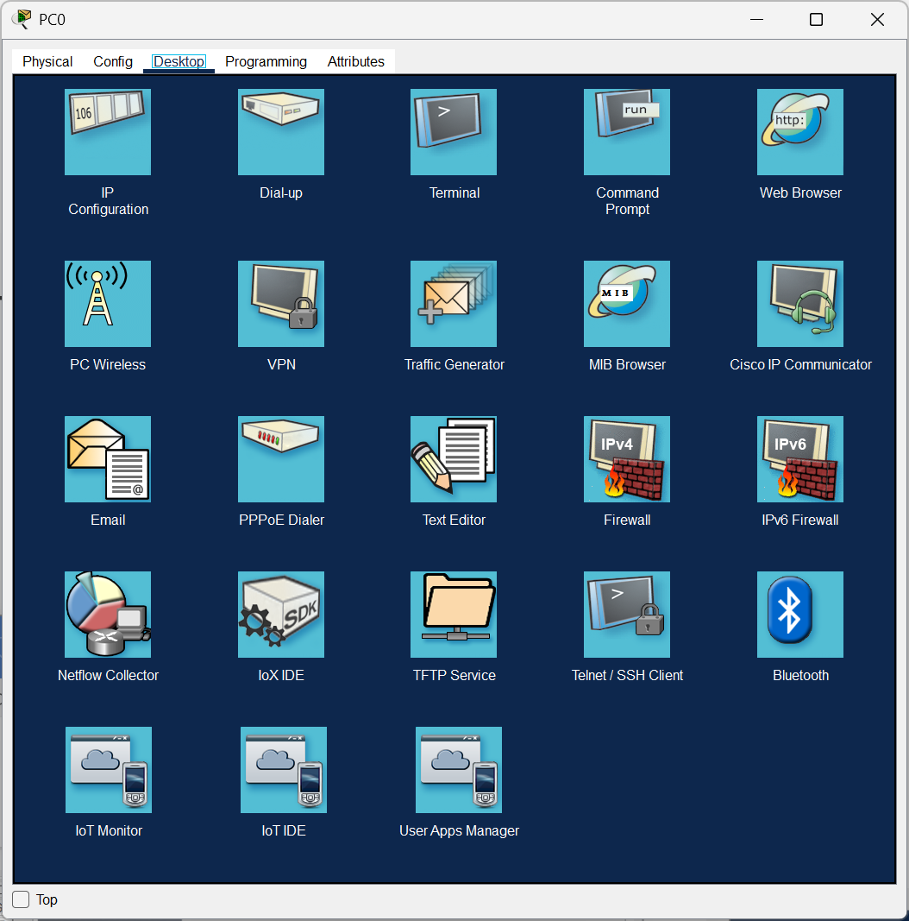

Configure PC0 with giving IP Address as **10.0.0.1**

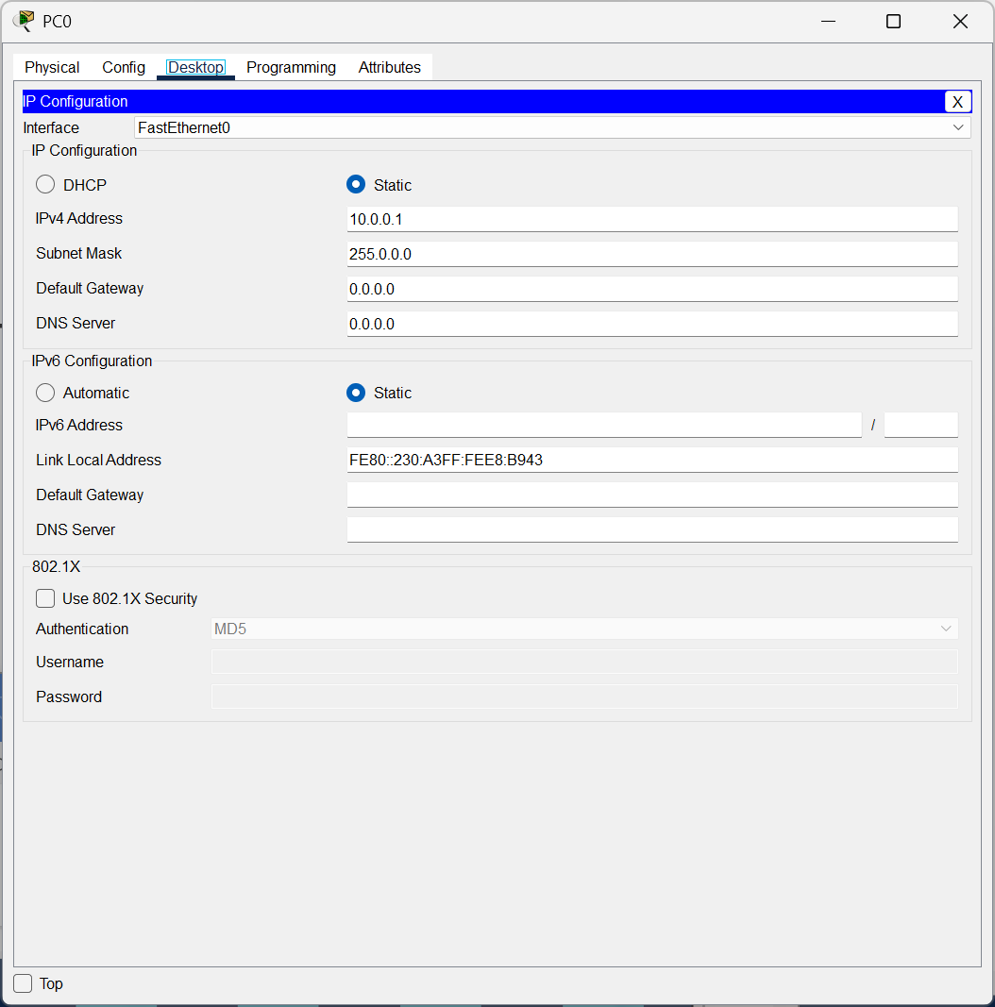

**Open the Command Prompt for IP Configuration Check.**

1. Click on the PC (e.g., **PC0**).
2. Navigate to **Desktop > Command Prompt**.



Run the **ipconfig** Command

1. Type the following command and press Enter:

**ipconfig**

1. The output will display the IP configuration of the PC. Example output:

FastEthernet0 Connection:

IP Address: 10.0.0.1

Subnet Mask: 255.255.255.0

Default Gateway: (none)

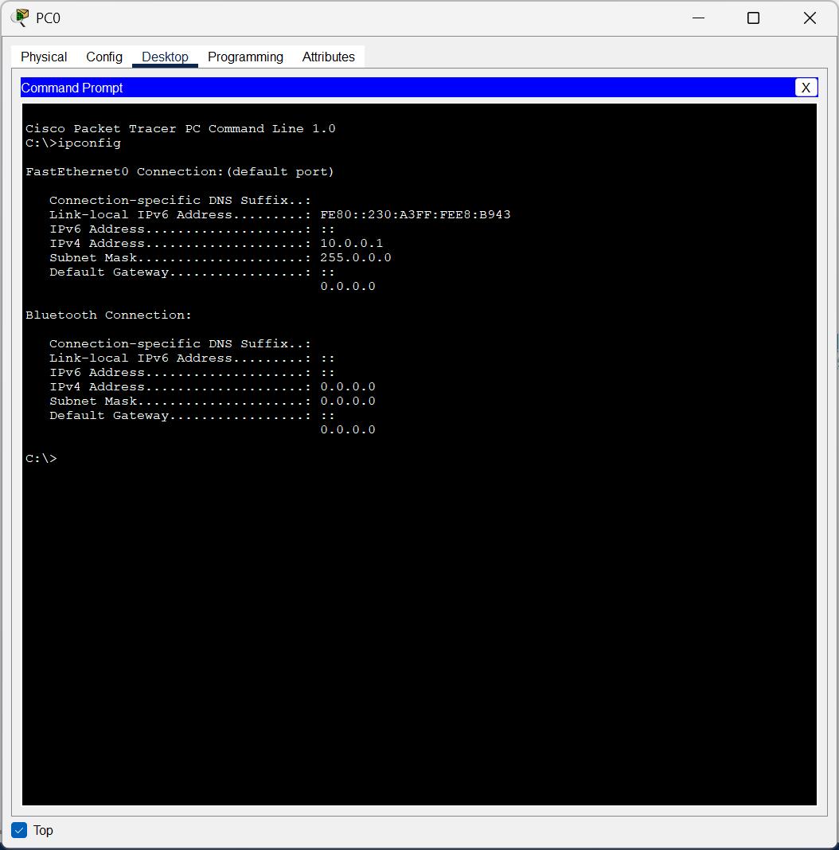

Configure PC1 with giving IP Address as **10.0.0.2**

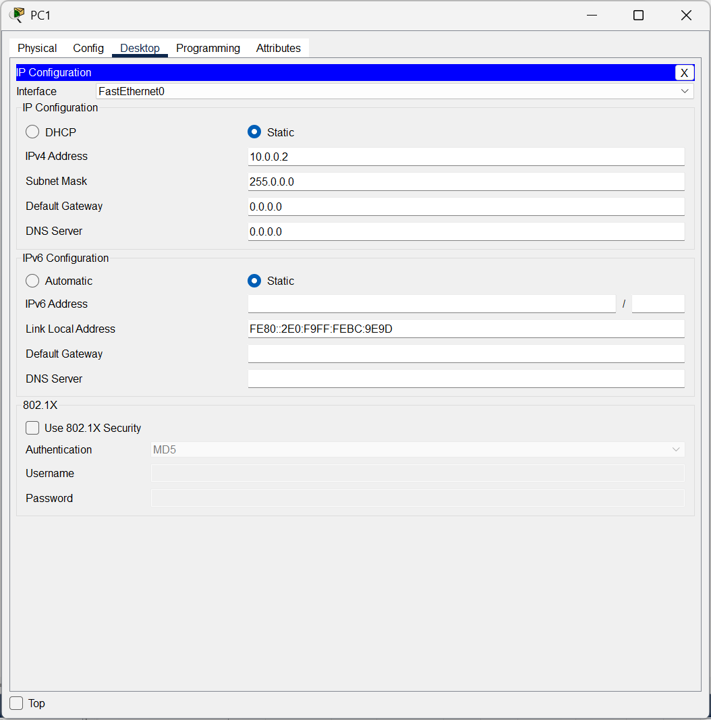

Run the **ipconfig** Command

* Type the following command and press Enter:

**ipconfig**

* The output will display the IP configuration of the PC. Example output:

FastEthernet0 Connection:

IP Address: 10.0.0.2

Subnet Mask: 255.255.255.0

Default Gateway: (none)

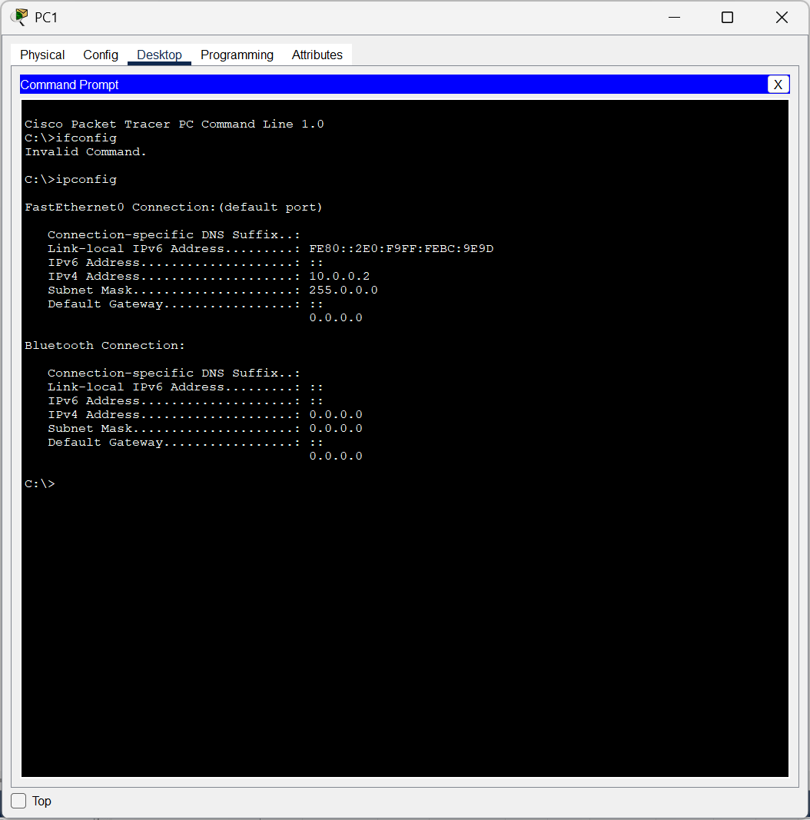

**Test Connectivity with Ping Command**

1. On **PC1**, go to **Desktop > Command Prompt**.
2. Type the following command and press Enter:

ping 10.0.0.1

* + If the connection is successful, you will see replies like:

Reply from 10.0.0.1: bytes=32 time<1ms TTL=128

* + If the connection fails, you will see "Request timed out." Check the cable connection and IP configuration.

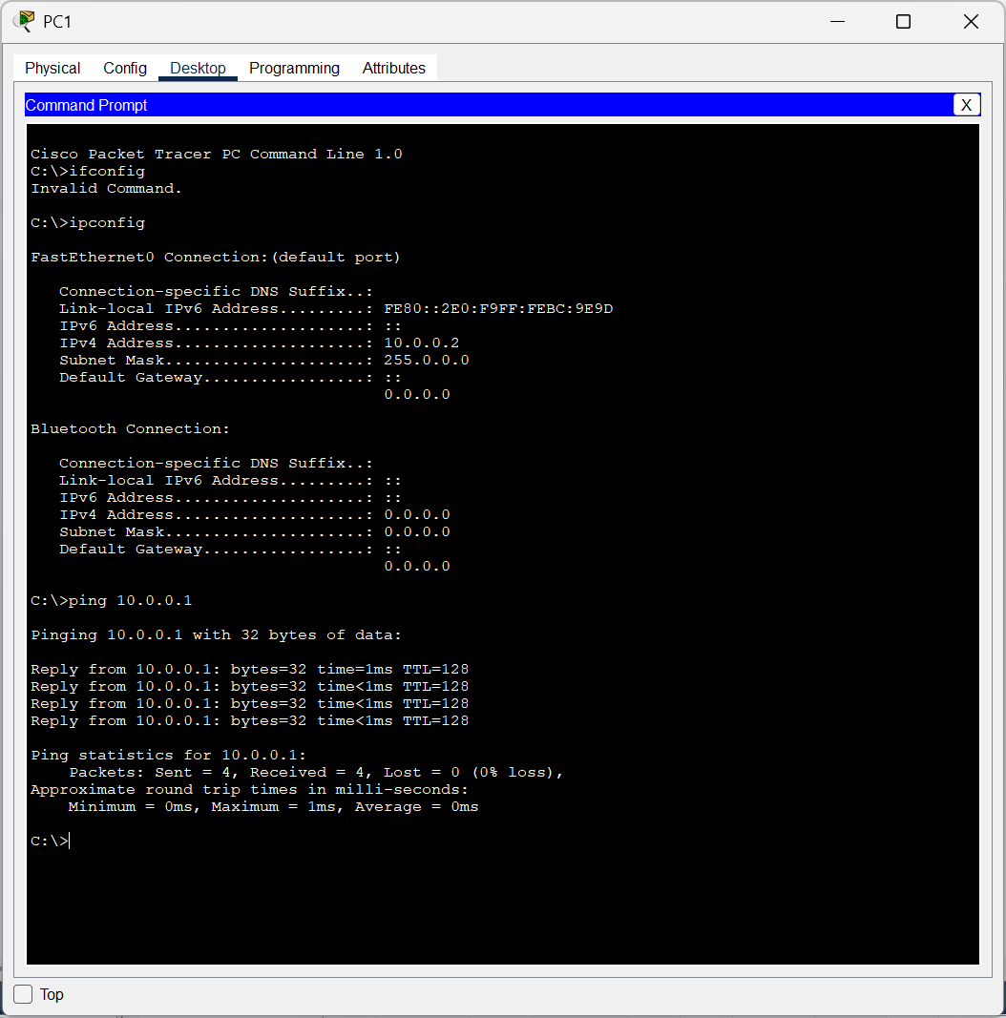

**Test Path Using Traceroute Command**

1. On **PC1**, go to **Desktop > Command Prompt**.
2. Type the following command and press Enter:

tracert 10.0.0.1

* + The output will show the path taken by the packets to reach the destination. Since there is only one hop in this setup, you will see:

Tracing route to 10.0.0.1 over a maximum of 30 hops: 1 <1 ms <1 ms <1 ms 192.168.1.2 Trace complete.

**CISCO PACKET TRACER DIGITAL REPRESENTATION**

***Representation of 2 PCs connected to each other and performing Network Connection Basic Commands.***

